NPS Enhancement Dtac/True - LLD Document

ENAAUGA Anubhav Agarwal A
Table of Contents
1. Project Overview 6
2. Solution Overview 6
2.1. BRD Reference 7
2.2. HLD Reference 7
2.3. TG2 Reference 7
3. Functional Flow 8
4. Solution Flow 9
5. PII Handling Strategy 16
6. Sample Input Data Sent to LLM 16
7. Data Engineering 16
7.1. Input Data 16
7.2. Detailed Data Flow Design 16
7.3. Data Lake Pipeline Queries (if applicable) 17
7.4. Data Preprocessing Pipeline 17
7.5. Data Normalization Pipeline 18
7.6. Data Source Path 18
7.6.1. Input Data Path 18
7.6.2. Normalized Data Path 19
7.7. KPI and Counter Details 19
7.8. Data Quality Checks 19
7.9. Data Purging Details 20
7.10. Argo WorkFlow Orchestration Details 20
7.11. Database schema (if applicable) 20
7.12. Database Detail – Postgres 22
7.13. Database Table Retention 22
7.14. Logging, alerts, reporting 22
7.15. Source Code Repository 23
7.16. Troubleshooting 23
8. Data Science Approach 23
8.1. Modelling EDA – Exploratory Data Analysis 23
8.2. Feature Engineering 24
8.3. Critical Data Elements (CDE) 24
8.4. Model Training & Parameters Tuning 24
8.5. Model Inferencing 24
1 24
8.6. Recommendation Details 24
8.6.1. Actuation Details (if applicable) 24
8.7. Model Performance 24
8.8. Detailed Model Flow Design 24
8.9. Argo WorkFlow Orchestration Details 25
8.10. Integration with Technical Dashboard 25
8.11. AI Explainability 25
8.12. Retraining Strategy 25
8.13. Source Code Repository 25
9. Front End Design 25
9.1. GUI Design 25
9.2. Integration Endpoints 25
9.2.1. Endpoint Payloads 26
GET /health 26
POST /session 26
DELETE /session/{session_id} 27
GET /session/{session_id}/response 27
POST /messages — SSE Investigation Stream 27
Session Management (Legacy / Frontend-Compatible) 27
POST /api/sessions 27
GET /api/sessions 27
POST /api/chat/{session_id}/message — SSE (Legacy) 28
GET /api/chat/{session_id}/messages 28
POST /api/chat/{session_id}/messages 29
9.2.2. Backend services SQL queries 30
9.3. Deployment Artefacts 30
9.4. Source Code Repository 30
10. CI CD Deployment 30
10.1. Deployment scripts 30
10.2. Source Code Repository 31
11. User Testing Scenarios 31
12. Dependencies & Constraints 31
2 Appendix 32
1. Glossary 32
2. Responsibility Matrix 32

Revision History

S N | Date | Change Description | Document Version | Prepared By /Modified By
1 | 27-07-2025 | First Draft | PA0.1 | Anubhav Agarwal

Project Overview
The NPS Enhancement initiative aims to create an AI-driven customer experience intelligence platform that integrates network performance, transmission, core, fault management, battery depletion, incident, customer complaint, and churn data into a unified analytical framework. The project focuses on normalizing and correlating these diverse data sources to identify relationships between customer experience metrics and underlying network performance indicators. By leveraging advanced AI/ML models, deep learning, anomaly detection, and LLM-powered analytics, the solution will uncover hidden patterns, predict future NPS trends, and proactively identify risks before they impact customers. The platform will categorize sites and regions into NPS bands, detect common problematic locations, perform automated root cause analysis, and recommend prioritized corrective actions. Ultimately, the objective is to enable proactive network optimization, reduce customer dissatisfaction and churn, improve operational efficiency, and drive sustained improvements in Net Promoter Score (NPS) through data-driven decision-making and predictive insights.

Solution Overview
The NPS Enhancement platform is an agentic AI system designed for telecom network operations teams. It enables operators to investigate NPS score degradation, correlate network alarms with customer impact, perform root cause analysis, and receive actionable recommendations -- all through a conversational chat interface.
The platform orchestrates 12 specialized AI agents that collaborate to answer complex multi-domain queries. Users can ask natural language questions like:
  - "Show top 10 impacted sites on 2026-07-15"
  - "Why is RYG7997 impacted?"
  - "Show alarms for that site" (context inherited from previous question)
  - "What is the root cause of availability degradation in the Western region?"
Key features:
- Natural language querying across NPS, alarms, KPIs, tickets, and topology data.
- Multi-turn conversations with automatic context inheritance.
- Progressive investigations that expand scope based on findings.
- Master orchestrator coordinating 12 specialized domain agents.
- Intelligent intent classification for optimal agent routing.
- Automated cross-domain investigations and evidence correlation.
- Root cause synthesis combining insights from multiple domains.
- Real-time investigation progress via Server-Sent Events (SSE).
- Live streaming responses with agent-level status updates.
- NL2SQL conversion across 13 telecom data tables.
- Automatic injection of site, region, and date filters into SQL.
- Multi-layer SQL validation to ensure contextual accuracy.
- Persistent investigation context stored in PostgreSQL.
- Automatic follow-up query context retention.
- Intelligent scope change detection and management.
- Guardrails to prevent context leakage and scope creep.
- AI-driven correlation of CX metrics with network indicators.
- Anomaly detection for proactive issue identification.
- LLM-powered complaint, sentiment, and churn analysis.
- Actionable recommendations with prioritized remediation insights.

[Provide reference to BRD, HLD, TG2]

BRD Reference
BRD Reference: NPS Enhancement_BRD.pptx

HLD Reference

HLD Reference: NPS_Enhancement_True_PA0.1_Insite_HLD.docx

TG2 Reference
NA

Functional Flow

Functional flow for Solution is as below:
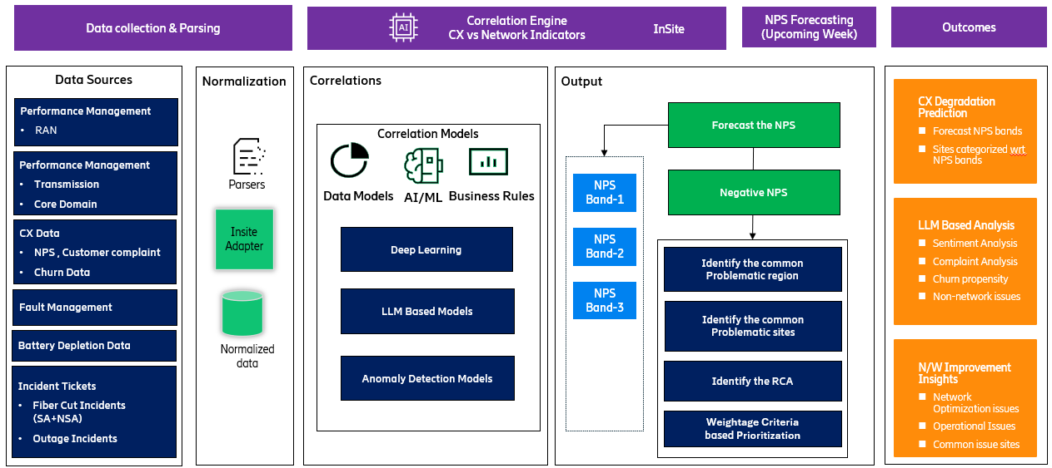
Figure 1: Functional Design of Solution

Solution Flow

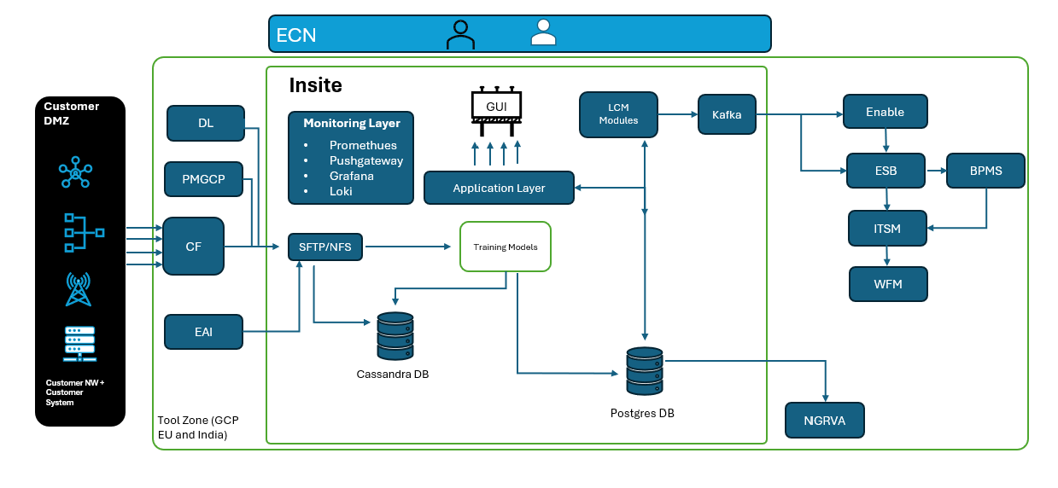
Figure 2: Insite Platform Architecture

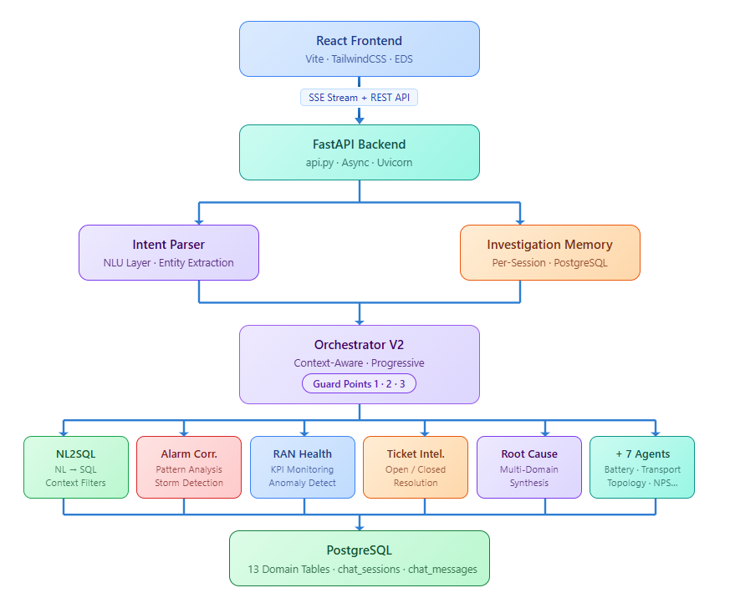
Figure 4: User Interface - Design Diagram

Here are key points for this architecture:
- Multi-Agent Orchestration — Orchestrator V2 coordinates 12 specialized agents (NL2SQL, Alarm Correlation, RAN Health, Ticket Intelligence, Root Cause, etc.) using a progressive invocation strategy — primary agent runs first, expansion agents triggered only when needed, minimizing latency and LLM cost.
- Context-Aware Investigation Engine — Investigation Memory persists site, date, and scope across conversation turns in PostgreSQL. Follow-up queries like "Show alarms for that site" automatically inherit context from prior turns — no need to repeat filters. Three guard points prevent context leakage and scope creep.
- NL2SQL with Active Filter Injection — The NL2SQL Agent converts natural language to SQL and injects active investigation filters (site, date) into every generated query. Multi-layer validation ensures generated SQL always respects the current investigation scope.
- Real-Time SSE Streaming — The FastAPI backend streams agent-by-agent progress to the React frontend via Server-Sent Events. Users see live investigation updates — which agent is running, what evidence was found — rather than waiting for a single final response.
- Dual-Layer Intent Routing — The Intent Parser (NLU layer) classifies each query before it reaches the orchestrator, separating fast retrieval queries (direct NL2SQL path) from deep investigation queries (multi-agent pipeline). This avoids spinning up the full agent pipeline for simple data lookups.
- Single PostgreSQL Source of Truth — All 13 domain tables (NPS, alarms, RAN KPIs, tickets, topology, etc.) plus chat sessions and investigation memory live in one PostgreSQL instance. This eliminates cross-service data sync issues and lets the NL2SQL agent join across domains in a single query.

How user interacts with application:
- User submits query via chat interface
- Intent Parser classifies the query (mode, type, entities, temporal references)
- Orchestrator V2 loads investigation memory from the database
- Context application: follow-up queries inherit site/date from previous turns
- Agent execution: primary agent runs first; expansion agents invoked if needed
- NL2SQL generates filtered SQL respecting active investigation context
- Results streamed back via SSE with agent progress events
- Investigation memory saved back to database for next turn

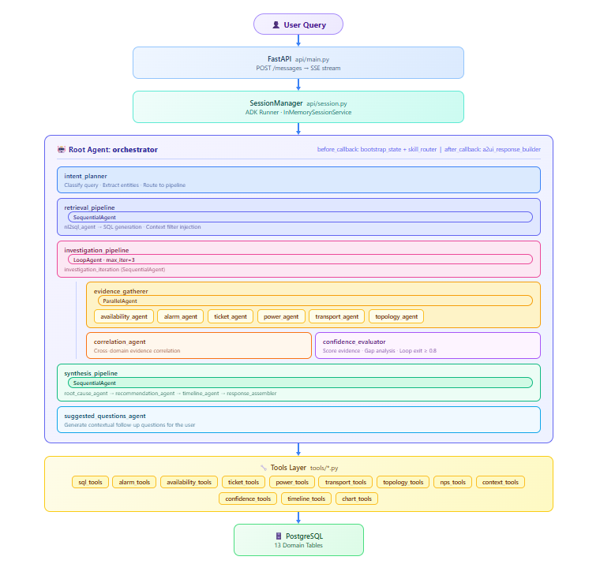
Figure 5: Agentic Flow - Diagram

Agent details:
Agent | Module | Responsibility
NL2SQL Agent | nl2sql_agent.py | Converts natural language to SQL queries; applies context filters
Alarm Correlation Agent | alarm_correlation_agent.py | Analyzes alarm patterns, correlates alarms across sites/time
RAN Health Agent | ran_health_agent.py | Monitors RAN KPIs, detects anomalies, trend analysis
Battery/Power Agent | battery_power_agent.py | Power and battery status monitoring
Transport Agent | transport_agent.py | Transport layer analysis and link health
Topology Agent | topology_agent.py | Network topology mapping and infrastructure issues
Customer Experience Agent | customer_experience_agent.py | NPS analysis, churn, complaints, sentiment
Ticket Intelligence Agent | ticket_intelligence_agent.py | Open/closed ticket analysis and resolution patterns
Root Cause Agent | root_cause_agent.py | Synthesizes multi-domain evidence into root cause hypotheses
Recommendation Agent | recommendation_agent.py | Generates actionable recommendations
Timeline Agent | timeline_agent.py | Builds chronological event timelines
Data Ingestion Agent | data_ingestion_agent.py | Data loading and preprocessing

Guard Points:

Guard | Location | Purpose
Guard 1 | Orchestrator (pre-agent) | Apply context inheritance BEFORE SQL generation
Guard 2 | Orchestrator (post-apply) | Validate question context matches investigation memory
Guard 3 | NL2SQL (post-generation) | Verify generated SQL includes all active filters

Python Libraries:
Python Package | SCAS Approved?
google-adk==2.5.0  google-genai==2.14.0  a2ui-agent-sdk==0.4.0  fastapi==0.139.2  uvicorn==0.51.0  sse-starlette==3.4.6  sqlalchemy==2.0.51  psycopg2-binary==2.9.12  asyncpg==0.31.0  pydantic==2.13.4  pydantic-settings==2.14.2  python-dotenv==1.2.2  pyyaml==6.0.3 | Yes  Yes  Yes  Yes  Yes  Yes  Yes  Yes  Yes  Yes  Yes  Yes  Yes

llm_settings:
- provider: "gemini"
- model: "gemini-3.1-flash-lite"
- max_tokens: 8192
- temperature: 0.1

agents:
- name: "orchestrator"
- enabled: true
- # ... 10 agent definitions

streaming:
- chunk_size: 512
- heartbeat_interval: 15

PII Handling Strategy
The platform operates exclusively on aggregated, site-level network and customer experience data. No PII enters the system at any stage — not in the database, not in LLM prompts, and not in logs.

Sample Input Data Sent to LLM
Example 1: Intent Classification Prompt

System: You are an intent classifier for a telecom NPS investigation platform.
Classify the user question into one of: retrieval, investigation, root_cause, comparison.
Extract entities: site_id, date, region, kpi_name.

User: "Why is RYG7997 impacted on 2026-07-15?"

Expected Output:
{
"intent_type": "root_cause",
"mode": "investigation",
"entities": {
"site_id": "RYG7997",
"date": "2026-07-15"
}
}

Example 2: NL2SQL Generation Prompt
System: Generate a PostgreSQL query for the following question.
Available tables: nps_enhancement_nps, nps_enhancement_alarms, ...
Active context: site_id = RYG7997, date = 2026-07-15
User: "Show alarms for that site"
Expected SQL:
SELECT date, siteid, total_alarms, active_alarms, description
FROM nps_enhancement_alarms
WHERE siteid = 'RYG7997' AND date = '2026-07-15'
ORDER BY total_alarms DESC;

Example 3: Root Cause Synthesis Prompt
System: Synthesize findings from multiple domain agents into a root cause hypothesis.
Input Evidence:
- Availability Agent: Site RYG7997 availability dropped to 92% (threshold: 98%)
- Alarm Agent: 14 critical alarms detected, 8 related to power
- Power Agent: Battery depletion event at 03:00, generator failed to start
- Ticket Agent: 2 open tickets for power issues, oldest 3 days
Expected Output: Structured RCA report with confidence score, timeline, and recommendations.
Data Sensitivity: Only site IDs, dates, KPI names, alarm codes, and aggregated counts are sent. No subscriber information, IP addresses, or authentication credentials are included in LLM interactions.

Data Engineering

Input Data
Following types of data are collected:
SN | Type of data | Source | Format | Frequency
1 | nps_enhancement_alarms | /persistent/insite_projects/esanvaj/onefm_alarm_data_new/ | Parquet | Daily
2 | nps_enhancement_battery | Battery_backup_history | DB TABLE | DAILY
3 | nps_enhancement_black_cells | /persistent/insite_projects/datalake_pipeline/Data/black_cell_4g/  /persistent/insite_projects/datalake_pipeline/Data/black_cell_5g/ | CSV | DAILY
4 | nps_enhancement_nps | /persistent/cf_data/true/sentiment_analysis_data/nps_comment/ | TEXT | Daily
5 | nps_enhancement_ran_daily_anomalies | /persistent/insite_projects/data/pmgcp/daily/ | CSV | Daily
6 | nps_enhancement_ran_daily_trend | /persistent/insite_projects/data/pmgcp/daily/ | CSV | Daily
7 | nps_enhancement_sites | Plauk Dong sites | CSV | static
8 | nps_enhancement_tickets | /persistent/insite_projects/NPS_enhancement/NPS_ENHANCEMENT_INCIDENT.parquet | Parquet | Daily
10 | nps_enhancement_weekly_chronic_down | /persistent/insite_projects/datalake_pipeline/Data/chronic_sites_down/ | CSV | Daily
11 | nps_enhancement_weekly_churn | /persistent/cf_data/true/sentiment_analysis_data/churn_data/Mobile_Churn_Request_and_MNP_Nationwide_*_masked.txt | TEXT | DAILY
12 | nps_enhancement_weekly_complaints | nw_complaint_analysis_gemini | DB | WEEKLY(DAILY)
13 | nps_enhancements_auto_tt_dual_cut_path_cache | auto_tt_dual_cut_path_cache | DB | DAILY
14 | nps_enhancements_auto_tt_dual_cut_path_cache_true | auto_tt_dual_cut_path_cache_true | DB | DAILY
15 | nps_enhancements_auto_tt_dual_cut_risk_cache | auto_tt_dual_cut_risk_cache | DB | DAILY
16 | nps_enhancements_auto_tt_dual_cut_risk_cache_true | auto_tt_dual_cut_risk_cache_true | DB | DAILY
17 | nps_enhancements_auto_tt_dual_cut_spof_cache | auto_tt_dual_cut_spof_cache | DB | DAILY
18 | nps_enhancements_auto_tt_dual_cut_spof_cache_true | auto_tt_dual_cut_spof_cache_true | DB | DAILY

Detailed Data Flow Design
Figure 6: Data Flow Diagram - Detailed

- The data is saved to Persistent Disk Storage.
- For PM Data Pipelines, data is pushed to Persistent Location – Daily Job
- Data Normalization and KPI generation scripts access this stored data and perform processing/normalization.
- Data is Aggregated at multiple levels of Aggregation – Province/ Band
- Normalized KPI data is used for Model Training (six months)

Data Lake Pipeline Queries (if applicable)
- DL Pipeline for PM Data were created by SDAP and are maintained at Insite Ops Team
- Jira reference:
- Project name: bmas-eu-dth-prod-data
- Frequency: Daily
- Target path: /persistent/insite_projects/data/pmgcp/
- File Format: Parquet

Data Normalization Pipeline
[Provide details about data normalization scripts, transformation logics and steps]

forecast.py - Jupyter Text Editor
alarm.py - Jupyter Text Editor
battery.py - Jupyter Text Editor
black_cell.py - Jupyter Text Editor
ran.py - Jupyter Text Editor
chronic_site_down.py - Jupyter Text Editor
complaint.py - Jupyter Text Editor
NPS.py - Jupyter Text Editor

All the scripts mentioned

Data Source Path

Input Data Path
Source
/persistent/insite_projects/esanvaj/onefm_alarm_data_new/
Battery_backup_history
/persistent/insite_projects/datalake_pipeline/Data/black_cell_4g/
/persistent/insite_projects/datalake_pipeline/Data/black_cell_5g/
/persistent/cf_data/true/sentiment_analysis_data/nps_comment/
/persistent/insite_projects/data/pmgcp/daily/
/persistent/insite_projects/data/pmgcp/daily/
Plauk Dong sites
/persistent/insite_projects/NPS_enhancement/NPS_ENHANCEMENT_INCIDENT.parquet
/persistent/insite_projects/datalake_pipeline/Data/chronic_sites_down/
/persistent/cf_data/true/sentiment_analysis_data/churn_data/Mobile_Churn_Request_and_MNP_Nationwide_*_masked.txt
nw_complaint_analysis_gemini
auto_tt_dual_cut_path_cache
auto_tt_dual_cut_path_cache_true
auto_tt_dual_cut_risk_cache
auto_tt_dual_cut_risk_cache_true
auto_tt_dual_cut_spof_cache
auto_tt_dual_cut_spof_cache_true

Normalized Data Path
In DB table, starting with nps_enhancement_*.

KPI and Counter Details
KPI details:
- RRC Connected users
- DL Traffic Volume
- DL PRB Utilization
- DL Throughput

Data Quality Checks
[Provide null checks, data integrity checks on raw and normalized data]

PM Data Validation scripts:
- Ericsson 4G:

- Ericsson 5G:

- Nokia 4G

- Nokia 5G

Note: These are not scheduled, validation was done during prod pipeline setup and sign-off.

Data Purging Details
[Provide data purging config details]

File Purging:
Purging Code Path –
persistent/insite_projects/true/purging_custom/
persistent/insite_projects/true/purging/

File Purging Config Path - config.yml - Jupyter Text Editor

Purging Argo Job name: true-data-purging-job
Schedule: Daily Once - 0 3 * * *

Argo WorkFlow Orchestration Details
[Provide details about argo workflows, scheduling, job name]

Argo Job Name | Frequency | Path | CPU/Memory

Database schema (if applicable)
[Provide details about db schema]
# | Table Name | Purpose
1 | nps_enhancement_sites | Site registry containing site IDs, circle, province, cluster, and region information.
2 | nps_enhancement_nps | NPS performance data by site and date, including promoter, passive, detractor counts, and sentiment metrics.
3 | nps_enhancement_ran_daily_trend | Daily RAN KPI trends by site, technology, vendor, and performance indicator values.
4 | nps_enhancement_ran_daily_anomalies | AI-detected KPI anomalies with severity levels, deviation percentages, and impacted metrics.
5 | nps_enhancement_alarms | Network alarm data including active, closed, and total alarm counts with detailed alarm information.
6 | nps_enhancement_battery | Site power and battery health information including battery events and related operational details.
7 | nps_enhancement_black_cells | Cell outage records showing black-cell occurrences and service availability impacts by site.
8 | nps_enhancement_open_tickets | Active trouble ticket repository containing open incidents, CI references, and issue descriptions.
9 | nps_enhancement_closed_tickets | Historical resolved ticket data including resolution actions and closure trends by site.
10 | nps_enhancement_weekly_chronic_down | Weekly chronic down-site tracking with recurring outage patterns and counts.
11 | nps_enhancement_weekly_churn | Customer churn analytics by site, operator, and churn category for retention analysis.
12 | nps_enhancement_weekly_complaints | Customer complaint records including complaint type, topic, sentiment, and issue categorization.
13 | nps_enhancement_topology | Network topology information containing links, paths, dependencies, and connectivity relationships.
14 | nps_enhancement_chat_sessions | Conversation session repository storing investigation context, metadata, and memory state.
15 | nps_enhancement_chat_messages | Detailed chat interaction history including user queries, agent responses, and message metadata.

Database Detail – Postgres
PROD:
IP: 172.29.185.12
Port: 5432
Db: insite
User: fe_user

Database Table Retention
Type of data | Days
nps_enhancement_alarms | 400
nps_enhancement_battery | 400
nps_enhancement_black_cells | 400
nps_enhancement_nps | 400
nps_enhancement_ran_daily_anomalies | 400
nps_enhancement_ran_daily_trend | 400
nps_enhancement_sites | 400
nps_enhancement_tickets | 400
nps_enhancement_weekly_chronic_down | 400
nps_enhancement_weekly_churn | 400
nps_enhancement_weekly_complaints | 400
nps_enhancements_auto_tt_dual_cut_path_cache | Daily
nps_enhancements_auto_tt_dual_cut_path_cache_true | Daily
nps_enhancements_auto_tt_dual_cut_risk_cache | Daily
nps_enhancements_auto_tt_dual_cut_risk_cache_true | Daily
nps_enhancements_auto_tt_dual_cut_spof_cache | Daily
nps_enhancements_auto_tt_dual_cut_spof_cache_true | Daily

Logging, alerts, reporting
[Provide details about logging, alerts and reporting mechanism]

- Monitoring and reports:
- GCP Alerts configured: GCP_Alerts_Cap_Forecasting_True.xlsx
- Log Path, pls find as below:

SN | Cap Forecasting Log Path
1 | /persistent/insite_projects/NPS_enhancement/logs

Source Code Repository
[Provide details about dev and prod Git repo]

capacity-forecasting · GitLab

  - ML Model Scripts -
forecast.py - Jupyter Text Editor
alarm.py - Jupyter Text Editor
battery.py - Jupyter Text Editor
black_cell.py - Jupyter Text Editor
ran.py - Jupyter Text Editor
chronic_site_down.py - Jupyter Text Editor
complaint.py - Jupyter Text Editor
NPS.py - Jupyter Text Editor

  - Argo Jobs

All the above scripts on daily basis.

Troubleshooting
[Provide details about troubleshooting common issues]

Troubleshooting-Doc-NPS_Enhancement-True 1.0.docx

Data Science Approach
Key EDA highlights:

Feature Engineering
The NPS Enhancement platform engineers 40+ features into a daily matrix (cis_features_daily) for ~162 sites. Features are derived from 8 groups: RAN KPIs (availability, drop rate, throughput — pivoted from daily trends), anomaly scores (count, severity, deviation %), alarm metrics (parsed from JSONB — diversity, duration, escalation), power/battery (backup hours, critical flags), service health (black cells, chronic down), topology/SPOF (single-point-of-failure grade, cascade impact), temporal (7-day rolling averages, trend slopes, day-of-week), and churn (weekly lagged, revenue-at-risk). Raw data is transformed via pivoting, JSONB parsing, rolling window computations, forward-filling weekly data to daily granularity, and joining static topology features — producing one row per site per day ready for anomaly detection and impact prediction models.

Critical Data Elements (CDE)
# | Critical Data Element | Why It Is Critical | Libraries / Packages Used
1 | NPS Score (nps_net) (per site/week) | Primary prediction target for forecasting future customer satisfaction | pandas, numpy, scikit-learn (regression), xgboost (forecasting)
2 | Site ID (site_id) | Master key used to join NPS, KPI, complaint, alarm, and topology datasets | pandas (merge/join), networkx (graph mapping)
3 | Site-to-Link Mapping (Topology) | Enables identification of common transmission links affecting multiple sites | networkx (graph traversal), scipy (sparse adjacency)
4 | Complaint Sub-Issue Category (16 classes) | Target label for Root Cause Analysis (RCA) classification | PyTorch (MLP classifier), xgboost, imbalanced-learn (SMOTE)
5 | RAN KPIs (172 metrics) | Primary input features for anomaly detection and prediction | numpy (z-score), scipy.stats (winsorization), pandas (rolling windows)
6 | Complaint Count | Validation signal and prioritization feature | pandas (aggregation), numpy (trend analysis)
7 | Transport KPIs (tnl_fail_rate, sctp_retrans, pkt_loss) | Detect transport-layer degradation and causal relationships | networkx (propagation), xgboost (link scoring)
8 | Fiber Alarm Status + Timestamp | Detect transport failures and propagate downstream impact | pandas (time-window joins), networkx (downstream dependency lookup)
9 | Subscriber Count / Revenue Impact | Business prioritization and revenue-at-risk estimation | numpy (normalization), pandas (weighted scoring)
10 | NPS Verbatim Text | Customer sentiment and qualitative feedback analysis | LangChain, OpenAI/Anthropic APIs, re (PII masking)
11 | Z-Score Anomaly Flags | Core anomaly detection feature used across prediction models | numpy (vectorized z-score), scipy.stats.zscore
12 | 13-Week NPS History | Time-series input for forecasting future NPS | xgboost, torch.nn.GRU, scikit-learn (Ridge Regression)
13 | Priority Score (Computed) | Final ranking metric for proactive intervention | numpy (weighted scoring), pandas (ranking & sorting)

Model Training & Parameters Tuning
[Capture all experiments in ML Flow]

Tokens: 8192
Temperature: 0.1
Model: Gemini-3.1-Flash-Lite

Model Inferencing
[Provide details of complete inferencing steps from normalized to final recommendation]

Recommendation Details
[Provide details of configuration tables (scenario, issue_type, recommendation_type, recommendation_rules), RecoLCM URL, JSON payloads]

- Not Applicable

Actuation Details (if applicable)
[Provide details of actuation and its corresponding Kafka JSON payloads]
- Not applicable

Model Performance
The proposed models will be evaluated using a combination of statistical, predictive, and business-centric metrics. The Isolation Forest anomaly detection model will be assessed based on its ability to detect site-days associated with SA tickets (Detection Rate ≥80%), maintain high Precision@100, and minimize false positives. It will be trained using only healthy site-days (no SA/PSA tickets and availability ≥99%) with n_estimators=200, contamination=0.05, and max_features=0.8.
The LightGBM Incident Predictor will be evaluated using Precision@Top-50, Recall@0.5 (≥60%), AUROC (>0.75), and probability calibration through Platt scaling. The model will be trained on data from March 15 to June 15, validated on June 16–30, and tested on July 1–16, with class imbalance handled using a 1:15 class weight.
The combined Customer Impact Score (CIS) will be validated by measuring its ability to identify future SA tickets, customer churn, complaints, revenue impact, and NPS degradation. Success criteria include Precision ≥40% for high-risk alerts, Recall ≥60% for SA incidents, Spearman correlation ≥0.3 with churn, false positive rate ≤30%, and positive directional agreement with complaint volume and NPS trends.
The LLM-based investigation pipeline will be evaluated on intent classification accuracy (>95%), investigation response time (10–60 seconds), retrieval latency (3–15 seconds), context inheritance across follow-up queries, and SQL generation accuracy. Based on validation results, CIS component weights, severity thresholds, churn multipliers, and domain-specific business rules will be calibrated to improve overall precision and operational effectiveness.

Detailed Model Flow Design
Figure 8: Model Flow Diagram

Argo WorkFlow Orchestration Details
[Provide details about argo workflows, scheduling, job name]
For Argo Details - Refer section 3.9

Integration with Technical Dashboard
The proposed system will be integrated into the existing technical dashboard to provide a unified view of network health, predicted incidents, and customer impact. Each site will display the Customer Impact Score (CIS) along with anomaly scores, incident risk, active alarms, and key performance indicators (KPIs). The dashboard will enable engineers to prioritize high-risk sites, investigate root causes through the LLM-powered assistant, visualize historical trends, and monitor customer-centric metrics such as complaints, churn, revenue impact, and NPS. This integration supports proactive network operations by combining real-time monitoring, predictive analytics, and AI-driven investigation within a single interface.

AI Explainability
To ensure transparency and build operator trust, the proposed system incorporates AI explainability at every stage of the prediction pipeline. The anomaly detection and incident prediction models provide the key KPIs and features contributing to each prediction, while the LLM generates concise, human-readable explanations describing why a site has been assigned a particular risk level or Customer Impact Score (CIS). The system also presents supporting evidence, such as abnormal KPI trends, active alarms, historical incidents, and customer impact indicators, enabling engineers to understand, validate, and confidently act on the model's recommendations.

Retraining Strategy
To maintain model accuracy and adapt to evolving network conditions, the models will be retrained periodically using the latest operational data. The retraining process will incorporate newly observed incidents, KPI trends, alarms, and customer feedback to capture changes in network behavior and emerging failure patterns. Model performance will be continuously monitored using predefined evaluation metrics, and retraining will be triggered whenever performance degrades beyond acceptable thresholds or after a scheduled interval. Updated models will undergo validation before deployment to ensure consistent performance, reliability, and minimal operational disruption.

Source Code Repository
[Provide details about dev and prod Git repo]
Git Repo:
For details refer section 3.12

Front End Design

GUI Design

Integration Endpoints
Method | Path | Description
GET | /health | Liveness check
POST | /session | Create a new ADK investigation session
DELETE | /session/{session_id} | Clear session state
GET | /session/{session_id}/response | Fetch final structured response
POST | /messages | SSE — stream investigation events (primary)
POST | /api/sessions | Create session (legacy)
GET | /api/sessions | List all sessions
POST | /api/chat/{session_id}/message | SSE — legacy chat endpoint (frontend)
GET | /api/chat/{session_id}/messages | Fetch message history
POST | /api/chat/{session_id}/messages | Save a chat message
GET | /api/sessions/{session_id}/context | Get active investigation context
DELETE | /api/sessions/{session_id}/context | Clear investigation context
POST | /api/intent-classify | Classify intent without running pipeline
POST | /api/generate-sql | Generate & validate SQL for a question
GET | /api/context-registry | List all registered intent types
GET | /api/context-registry/{intent_type} | Get full context for an intent type

Endpoint Payloads

GET /health
Liveness check. Returns platform status, version, and engine.
Response
{
"status": "ok",
"version": "2.0.0",
"engine": "google-adk"
}

POST /session
Create a new ADK investigation session.
Request Headers
Header | Required | Description
x-user-id | No | User identifier (default: "default")

Response
{
"session_id": "abc123-uuid"
}

DELETE /session/{session_id}
Clear session state and reset investigation context.
Path Parameters
Parameter | Description
session_id | Session UUID

Response
{
"status": "cleared",
"session_id": "abc123-uuid"
}

GET /session/{session_id}/response
Fetch the final structured response from session state after a turn completes.
Path Parameters
Parameter | Description
session_id | Session UUID

Response — Text
{
"type": "text",
"message": "RYG7997 shows 23% availability degradation..."
}
Response — Table
{
"type": "table",
"data": { "rows": [ {...}, {...} ] }
}
Response — Empty
{
"type": "empty",
"message": "No response available yet."
}

POST /messages — SSE Investigation Stream
Primary chat endpoint. Streams investigation events as newline-delimited JSON via Server-Sent Events.
Request Body
Field | Type | Required | Description
new_message | string | Yes | Natural language query
adk_session_id | string | No | Session ID — auto-created if omitted
adk_user_id | string | No | User ID (default: "default")

Example Request Body
{
"new_message": "Why is RYG7997 impacted?",
"adk_session_id": "abc123-uuid",
"adk_user_id": "default"
}
SSE Event Types
type | Payload Fields | Description
loading | title, message | Pipeline started, analyzing request
investigation_start | mode | "retrieval" or "investigation"
agent_start | agent, message | Agent execution started (first time)
agent_activity | agent, status, message | Agent progress update
agent_complete | agent, ... | Agent finished with results
table | data: { rows: [...] } | SQL query result as structured data
text | message | Narrative response from agent
heartbeat | (empty) | Keep-alive ping every 8 seconds
error | title, message | Pipeline failure details
[DONE] | — | Stream complete (raw string, not JSON)

Example SSE Stream
data: {"type":"loading","title":"Processing...","message":"Analyzing your request..."}
data: {"type":"investigation_start","mode":"investigation"}
data: {"type":"agent_start","agent":"~intent","message":"Classifying intent..."}
data: {"type":"agent_start","agent":"~availability","message":"Checking availability..."}
data: {"type":"agent_start","agent":"~alarms","message":"Analysing alarms..."}
data: {"type":"agent_complete","agent":"~availability"}
data: {"type":"table","data":{"rows":[{"site":"RYG7997","availability":77.2}]}}
data: {"type":"text","message":"RYG7997 shows 23% availability degradation..."}
data: [DONE]

Session Management (Legacy / Frontend-Compatible)

POST /api/sessions
Create a new session (legacy endpoint).
Request Body
{
"user_id": "default"
}
Response
{
"session_id": "abc123-uuid"
}

GET /api/sessions
List all sessions for a user.
Query Parameters
Parameter | Required | Default | Description
user_id | No | "default" | Filter sessions by user

Response
[
{
"session_id": "abc123",
"title": "RYG7997 investigation",
"created_at": "2026-07-21T10:00:00"
},
...
]

POST /api/chat/{session_id}/message — SSE (Legacy)
Legacy SSE chat endpoint used by the current frontend. Identical event stream to POST /messages.
Path Parameters
Parameter | Description
session_id | Session UUID

Request Body
{
"message": "Show top 10 impacted sites",
"user_id": "default"
}
Response: Same SSE event stream as POST /messages.

GET /api/chat/{session_id}/messages
Fetch full message history for a session from PostgreSQL.
Path Parameters
Parameter | Description
session_id | Session UUID

Response
{
"messages": [
{
"id": "uuid",
"role": "user",
"content": "Why is RYG7997 impacted?",
"created_at": "2026-07-21T10:00:00",
"metadata": {}
},
{
"id": "uuid",
"role": "assistant",
"content": "RYG7997 shows 23% availability degradation...",
"created_at": "2026-07-21T10:00:05"
}
]
}

POST /api/chat/{session_id}/messages
Save a chat message to PostgreSQL for persistence across restarts.
Path Parameters
Parameter | Description
session_id | Session UUID

Request Body
Field | Type | Required | Description
role | string | Yes | "user" or "assistant"
content | string | Yes | Message text (max 10,000 chars)
metadata | object | No | Optional structured metadata

{
"role": "user",
"content": "Show alarms for that site",
"metadata": {}
}
Response
{
"status": "saved",
"id": "uuid"
}

Backend services SQL queries
Based on the question it will be generating the NL to SQL.

Deployment Artefacts
Workload details:
  - npsenhancement-gui
  - npsenhancement-rest-api
Namespace: insite-dtac-prod

Source Code Repository
Model scripts: bss-eu-gcp-insite / AIML Model / TRUE-DTAC / nps-enhancement / model-scripts · GitLab
Argo Jobs: bss-eu-gcp-insite / AIML Model / TRUE-DTAC / nps-enhancement / argo-scripts · GitLab
sql scripts: bss-eu-gcp-insite / AIML Model / TRUE-DTAC / nps-enhancement / sql-scripts · GitLab

CI CD Deployment
The proposed system will be deployed using a Continuous Integration and Continuous Deployment (CI/CD) pipeline to enable reliable and automated software delivery. Source code changes will be automatically tested, built, and deployed through version-controlled workflows, ensuring consistent releases with minimal downtime. The deployment pipeline will include automated validation, unit and integration testing, containerized deployment, and monitoring to verify system health after each release. This approach enables rapid feature updates, seamless model deployment, rollback support, and improved reliability for production AI services.

Deployment scripts
[Provide details about docker file, Gitlab runner file, GCP secrets]
Deployment scripts automate the installation, configuration, and execution of the proposed system across different environments. These scripts handle tasks such as environment setup, dependency installation, model deployment, database migrations, service initialization, and application startup, ensuring consistent and repeatable deployments. By automating deployment activities, the system minimizes manual intervention, reduces configuration errors, and enables faster, more reliable releases across development, testing, and production environments.

Source Code Repository
Refer section 3.15

User Testing Scenarios
User testing will be conducted using representative operational scenarios to validate the functionality, usability, and reliability of the proposed system. Test cases will include monitoring high-risk sites, investigating predicted incidents, querying the LLM assistant for root cause analysis, reviewing Customer Impact Scores (CIS), and verifying alerts against actual network events. Users will also evaluate dashboard responsiveness, explanation quality, and the accuracy of recommendations. Feedback from network engineers and stakeholders will be used to refine the user interface, improve AI explanations, and enhance the overall user experience before production deployment.

Dependencies & Constraints
The proposed system depends on the availability of reliable network KPI data, alarm logs, service assurance (SA) tickets, customer complaint records, and cloud infrastructure for data processing, model training, and deployment. It also requires integration with existing databases, monitoring platforms, and the LLM framework for intelligent investigation. Key constraints include data quality and completeness, evolving network behavior, class imbalance in incident data, computational resource requirements for model training and inference, and the need to meet real-time response requirements while ensuring scalability, security, and compliance with organizational policies.

Appendix

Responsibility Matrix
Sr. No | Role | Name
1. | SDL | Sandeep K R Vajrala <sandeep.k.r.vajrala@ericsson.com>
2. | User of the model | Dtac/True Customer
3. | Customer Project Manager | Sandeep K R Vajrala <sandeep.k.r.vajrala@ericsson.com>
4. | Solution Architect | Anubhav Agarwal A <anubhav.a.agarwal@ericsson.com>
5. | Data Scientist(s) | rishita.gagrani@ericsson.com
6. | Full Stack Developer | NA
7. | SME | Ajay Sharma B <ajay.b.sharma@ericsson.com>
8. | LCM L2 team | Abhishek Kumar J <abhishek.j.kumar@ericsson.com>
9 | Connection Factory (CF) | Puneet Kumar B <puneet.b.kumar@ericsson.com>; Prakhar Mohan Somani <prakhar.mohan.somani@ericsson.com>
10 | Enable Team | NA
11 | PMGCP | Rakesh Gupta A <rakesh.a.gupta@ericsson.com>; Devesh Srivastava <devesh.srivastava@ericsson.com>

